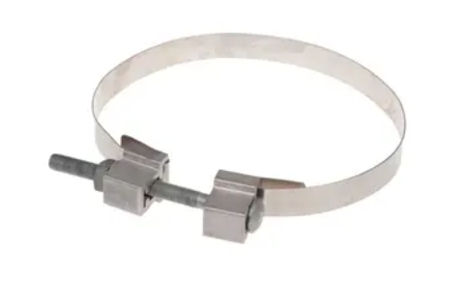 | Kit with 84 " of 3/4" Stainless Steel Banding , One AB002 Adjustable Buckle
by TTF POWER TECHNOLOGY CO.,LTD
Catalog ID: KSSB8434
Banding kit used as a no-drill method of securing components to poles of any material or shape.
Kit includes 84" of 3/4" stainless steel banding and one AB002 adjustable buckle
PRODUCTS DETAILS

General
Material | Stainless Steel
Type | Banding Components

Dimensions

Distance From Pole | N/A
Length | 84 in / 2134 mm
Width | 0.75 in / 19 mm

For further technical assistance, please contact us
TTF POWER TECHNOLOGY CO. , LTD
Rm. 609-610 Tianjin Technology Financial Building, Tianjin, China, 300384
Phone: +86-22-85233528
Mobile: +86-15510864645
Email: ttfintlcs@ttfpower.com

